DSC 430: Python Programming  
Assignment 0502: Cups and Dice

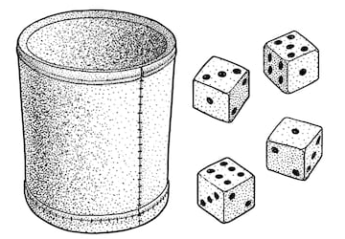

For this problem you will use the classes from the previous problem to build a game. The game will work as follows:

1. Greet the user and ask their name.
2. Provide the user with a balance of 100 dollars.
3. Ask them if they would like to play a game.
4. Generate a random number between 1 and 100. This number will be called the goal.
5. Ask the user how much they would like to bet. This money is deducted from their account.
6. Ask the user how many of each die they would like to roll.
7. Create a cup filled with dice according to the user’s input.
8. Roll the cup and display the results.
9. If the roll exactly matches the goal, the user receives 10x bet added to their balance.
10. Otherwise, if the roll is within 3 of the goal but not over, the user receives 5x bet added to their balance.
11. Otherwise, if the roll is within 10 of the goal but not over, the user receives 2x bet added to their balance.
12. Report the results to the user. The message should include their name and updated balance.
13. Ask if they would like to play again. If so, go to step 4.

Record a three minute video in which you run the code. Then, present your code. Specifically, answer the following questions:

* Show your primary loop and brag about how clean it is because you practiced top-down development.
* Describe how you leverage the dice and cups classes from the previous assignment. Use the classes – don’t store a bunch of values in the game engine that you need!
* What happens if the user bets a negative amount and then purposefully loses the game? Do you subtract a negative amount (add) to their account?

Submission: Submit a single .py file containing all the code to the D2L. Do not zip or archive the file. Your code must include comments at the top including your name, date, video link, and the honor statement, “I have not given or received any unauthorized assistance on this assignment.” Each function must include a docstring and be commented appropriately.